Objective

The objective of this test is to ensure that the SimpleDose Storage is monitored by the application Team with alerts configured for notifying the Data Base Analysts when thresholds limits are met.

Procedure

- Ensure that thresholds for key performance metrics are configured appropriately
- Ensure that alerts are being addressed and communicated appropriately to relevant parties.

Results/Observations

A.2.1 – Thresholds for key performance metrics are configured appropriately.

Internal Audit (IA) obtained the SimpleDose PROD MIR3 from William L Mullins, Director, IT Pharmacy Systems on May 18th, 2021 (SDA PROD MIR3). After reviewing the document, IA observed that there are SDA Prod monitoring actions set in place to automatically run at specific time interval every day for Tier 1 through 5; Tier 1 being the lowest hierarchy and Tier 5 being the highest. IA also observed that each of these SDA Prod monitoring activities configured based on Tier hierarchy show that they have been checked for approval by the responsible parties at each corresponding Tier levels.

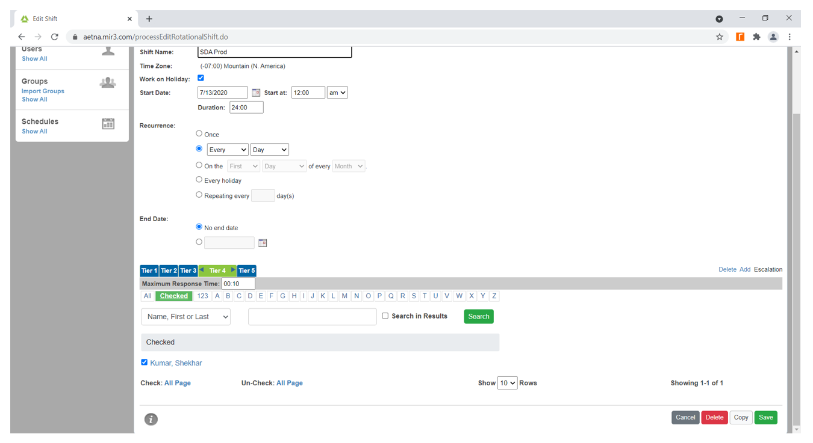

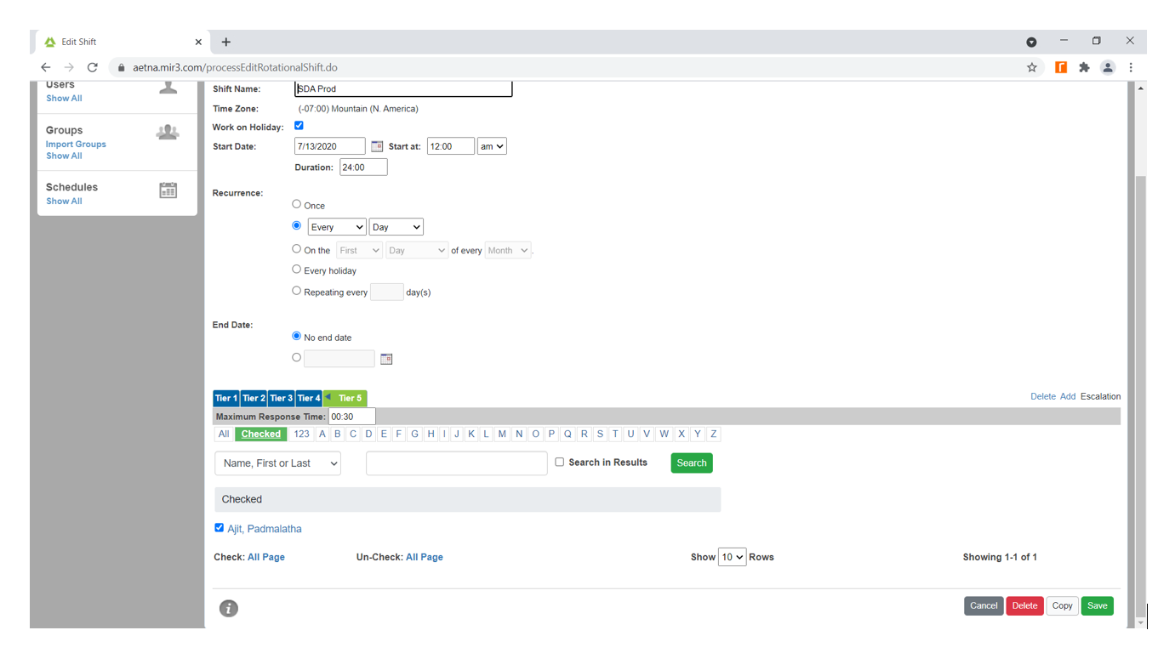
IA observed that Padmalatha Ajit (Senior Manager, Application Development) receives alerts when performance metrics have been escalated to the highest level, Tier 5

As such, IA concludes that thresholds for key performance metrics are configured appropriately. No action items or exceptions were noted.

A.2.2 – Alerts are being addressed and communicated appropriately to relevant parties.

Internal Audit (IA) obtained an email thread conversation between members of SimpleDose Application support Team detailing the monitoring agents associated with SimpleDose from Michael Dennen, Senior Manager, IT Systems on June 1st, 2021 (MPK Server File Systems). In the email provided, there are screenshots of PING status showing the note status of monitoring agents if they are active online, running and communicating back. IA also observed the monitoring intervals communicated to agents showcasing how often they check and persist count showing the number of consecutive “true” conditions in a row needed to trigger an alert. All of these situations are processed on the Omnibus server. They include the situation name, server, ad application ID which are used to determine who gets alerted. IA noted that certain groups are sent a formatted alert to OBM and then on to MIR3 for processing. The standard thresholds for warning and criticalities as provided in the email thread by Michael showcased a 75% email and 85% page. It was also noted that the DEV servers are set for email, but not currently alerting at the moment.

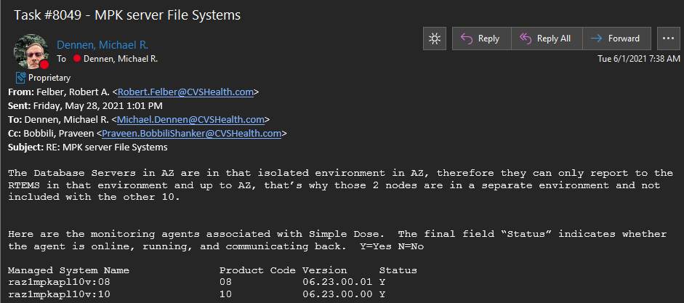

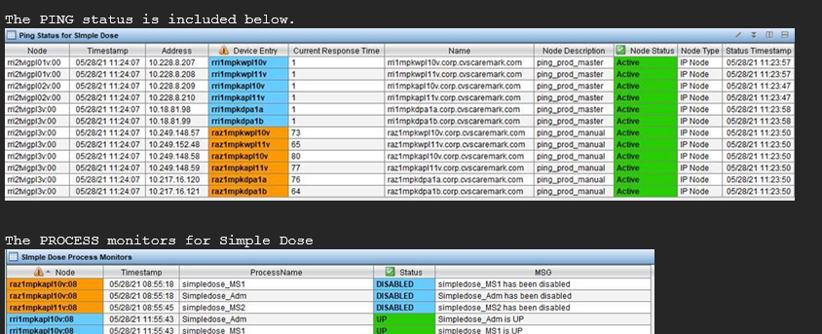

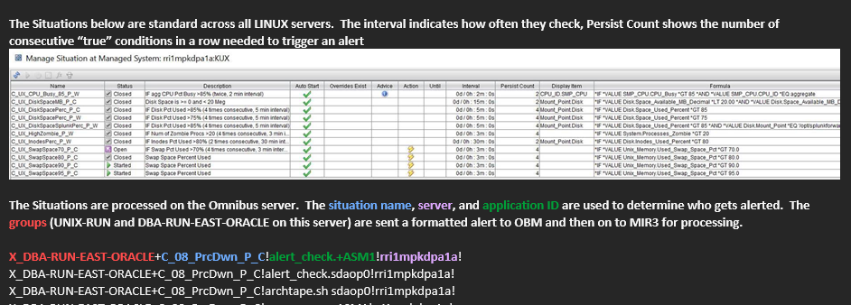
As such, IA concludes that alerts are being addressed and communicated appropriately to relevant parties. No action items or exceptions were noted.

Conclusion

This Control appears to be operating effectively.

